***Car Speed Limit***

***Description***

* *This is an Android application that calculate the speed while being in a vehicle and if the speed exceeded the limit speed a notification appears to notify the user.*

***Usage***

* *When the user opens the application this screen opens at first and the user has to enter the speed limit then press on the OK button.*

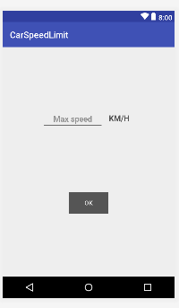

* *Then a new page opens which contains the speed of the vehicle*

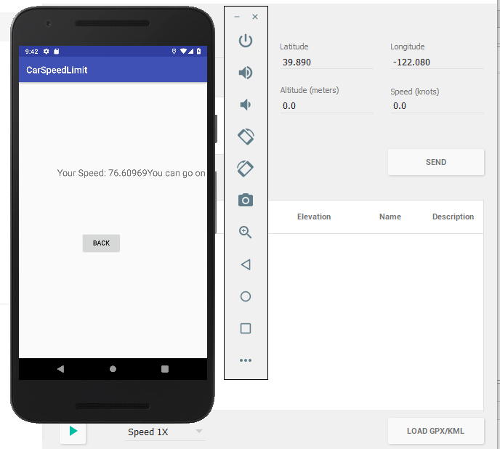

* *If the user exceeded the speed limit the app will notify the user*

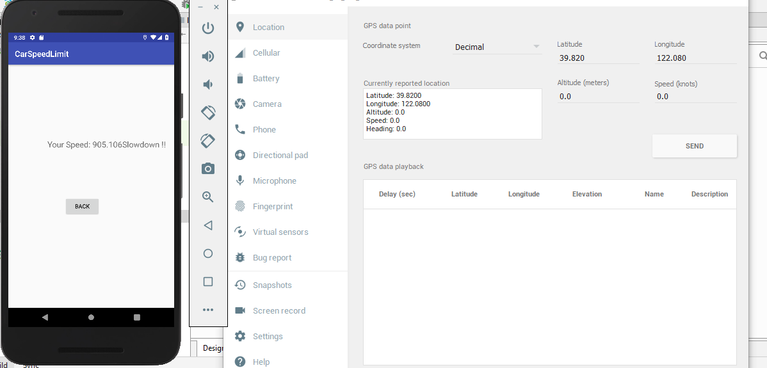

* *If the user wants to change the car speed limit the user should click on the back button to return to the car speed limit page again.*